SOUTHAMPTON SOLENT UNIVERSITY

SCHOOL OF MEDIA ARTS AND TECHNOLOGY

BSc (Hons) Web Design and Development

Academic Year 2016-2017

N.HOCKEY

Researching, designing and testing a cloud-based resource scheduling application for small – medium sized creative teams

Tutor: M.Reid May 2017

This report is submitted in partial fulfilment of the requirements of Southampton Solent University for the degree of BSc (Hons) Web Design and Development

# **List of Contents**

List of Contents 2

List of Figures 3

List of Tables 4

Acronyms 5

1. Introduction 6

2. Aim and Objectives 8

3. Literature Review 10

5. Methodology 18

6. Design 21

**User Research** 21

**Personas** 23

**User Journey and Empathy Mapping** 24

**Mood Boards** 24

**Site Map** 24

**Wireframes** 25

**Design** 26

**Prototyping** 27

7. Issues arising from Implementation and Test / Conduct of the Investigation 29

8. Results 30

9. Evaluation and Conclusions 31

10. Recommendations for Further Work 32

10. Appendices 33

**Appendix X – Survey Results** 33

**Appendix X – User Interviews** 36

**Appendix X – Personas** 48

# **List of Figures**

Figure 1: The Idea Bureau Website

Figure 2: Basic Gantt Chart Diagram

Figure 3: Types of Dependencies

Figure 4: 2016 Tech Nation Report

Figure 5: Usability Testing Statistics Nielsen Norman

# **List of Tables**

# **Acronyms**

IA – Information Architecture

UI – User Interface

UX – User Experience

# **1. Introduction**

The Gantt chart was created in 1903 by Henry Laurence Gantt with the purpose helping to manage and plan projects according to Trainer (2012). These charts are used as a visual way of documenting the duration of a project and its progress. Gantt (2016) reveals that years ago these charts were prepared by hand, however in a projects life-cycle schedules change and this is a natural occurrence. When this does inevitably happen the Gantt charts need to be amended / redrawn in order to remain consist with a projects schedule. As soon as the Gantt chart comes out of sync with the project it becomes redundant. Managing client expectations then becomes impossible. On both small and large scale projects this was not a convenient medium for Gantt charts to exist.

When personal computers became available in the 1980s, digital and more complex Gantt charts could be created. This meant that the natural changes in a projects life-cycle could be better managed and conveyed to teams. Paymo (2016) states that as Gantt charts became accessible on web-based application the popularity of this project management tool increased. Gantt charts are one of the most popular project management scheduling tools in the creative industry according to Heaton (2016b). These charts became digitalised over 100 years ago, yet user’s needs are still unfulfilled, especially within the creative industry.

This project is a result of the team at The Idea Bureau wanting to create a product to help solve the issues with managing projects in creative teams. The Idea Bureau is a small digital workshop located in Taunton, Somerset. The company’s ethos is to create engaging digital experiences that have a positive impact around the world. After having tried and tested a vast amount of project management tools in the industry, The Idea Bureau feel that it is now time to design and build a tool that can work for creative teams effectively. The Idea Bureau’s website can be found at [www.theideabureau.co](http://www.theideabureau.co) and Figure 1 provides a preview of the website.

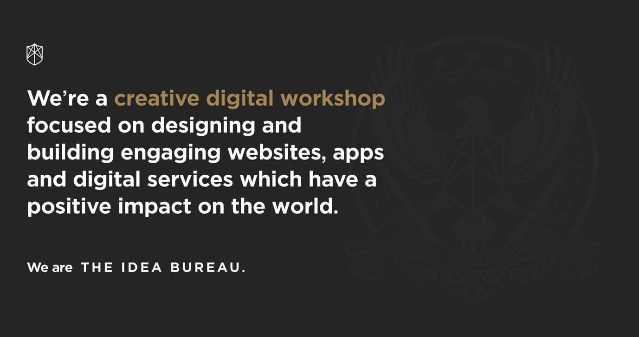

**Figure 1 – The Idea Bureau Website**

Working alongside the team at The Idea Bureau is going to involve being in constant communication about the different phases of this project. Having regular meetings and check-ins will be essential in the progression and high quality delivery of this project.

# **2. Aim and Objectives**

The aim of this project is to identify the growth in the creative industry and how there is a demand for project management tools within this industry. A suitable solution will be designed based on users’ needs and the final output will be a clickable prototype.

1. Carry out research into the history of Gantt charts and the progression over the last 100 years, competitor’s analysis, the growth of the creative industry and how these charts are currently used in the industry will be carried out to gain a solid understanding. This research will be achieved by 19th March 2017 and roughly 50 hours will be spent on this.
2. Carry out quantitative and qualitative research into user’s behaviours to an industry based standard. The data gained from this will inform design solutions and the overall user experience of the end product. 10 hours will be spent on this and it will be done by 29th March 2017.
3. Analyse research findings in order to identify trends and anomalies before moving forward and creating personas, user journey’s and empathy maps. A UX workshop will be essential so that research findings can be shared with the team at The Idea Bureau. A total of 20 hours will be spent on this and it will be achieved by 4th April 2017.
4. Using the research gathered wireframes and rapid prototyping will be done to allow for exploration of IA and UI components. This will be done by 13th April 2017 and 10 hours will be spent on this.
5. This will result in high fidelity designs created in Sketch, an industry standard UI design tool. These designs will then be synced with InVision to create a professional prototype for user testing purposes. 50 hours will be spent on this and it will be finished by 23rd April 2017.
6. The final clickable prototype will be tested on 5 users at Southampton Solent University. All of this data will be analysed and necessary design improvements will be considered. 15 hours will be spent on this and it will be done by 3rd May 2017.

# **3. Literature Review**

With milestones and deadlines constantly changing, project management is a difficult task, no matter what sized team. Teams can easily fall behind if there is no effective guidance and tracking from a project manager, and this is why Gantt charts are a beneficial way of dealing with client / team member’s expectations. Nishadha (2012) reveals that Gantt charts provide a visual representation of the project pipeline and what is expected.

A Gantt chart is the best graphic available for project managers as it is the most useful and insightful diagram. Figure 2 shows a basic diagram of a Gantt chart.

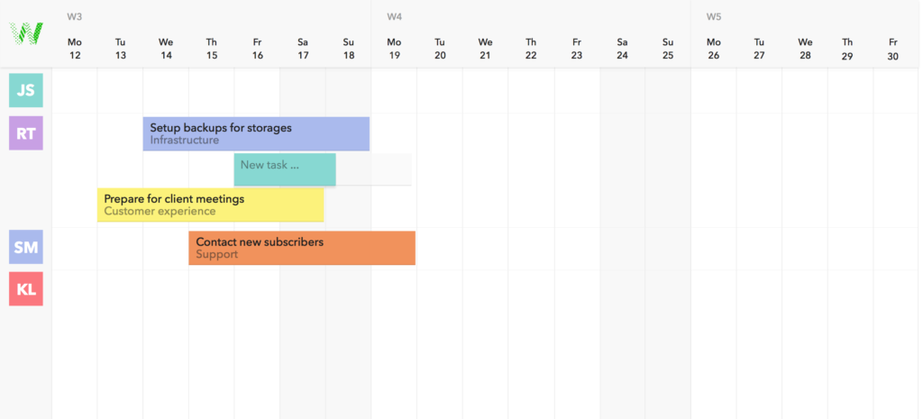

**Figure 2 – Basic Gantt Chart Diagram**

However, Gantt charts do come with issues. The common errors behind these issues are:

* Providing too much information
* No consideration for version control

It can be tempting to start adding multiple layers to Gantt charts, but this only increases the upkeep and is visually overwhelming. As a project evolves maintenance is required and more often than not there is no backlog showing the history of a project. Harper-Smith and Dery (2012, pp. 141 – 142) writes how having the visual understanding of a projects evolution is priceless.

In recent years drag and drop functionalities have been implemented into most online Gantt chart software. This makes it easier to add tasks, create dependencies and update timeframes according to John (2011). Dependencies have become a staple feature and they are used between tasks that occur chronologically in a waterfall methodology. This means that if a task is delayed then the remaining project pipeline will adapt to accommodate for this writes Valdellon (2014). Dependencies refer to data relationship between tasks and there are four main types. These are finish to start, start to start, finish to finish and start to finish. All of these could exist within a single Gantt chart project reveals Project Insight (n.d). Figure 3 is a diagram showing how these four types of dependencies appear visually.

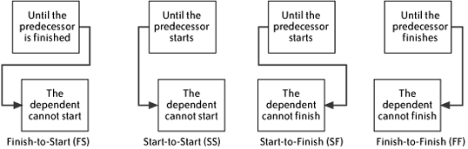

**Figure 3 – Types of Dependencies**

There is an ongoing debate as to whether or not Gantt charts can fit into an agile workflow. Woo (2014) explains that Gantt charts are still beneficial as they are quick to communicate whether a project is on track. Dependencies are also a crucial feature needed, even in an iterative process.

Within an iterative process there are still layers that make up an iteration or a sprint and these can be visualised in a Gantt chart. However, Sutherland (2006) who invented Scrum in 1993 (a smaller version of the agile methodology) banned the use of Gantt charts. This was because even after the first working day the chart would be outdated and the maintenance of this would be too much. Even after 13 years Jeff Sutherland still frowned upon mixing Gantt charts with an agile / scrum methodology. Croft (2015b) reveals that there has been a lot of competition and rivalry between the two methodologies and which ones are suitable for managing creative teams. Waterfall, agile and scrum methodologies are the main contenders but they all bring advantages and disadvantages. Agile and scrum do not allow for planning of duration and costs, which is why Jeff Sutherland was against the usage of Gantt charts. However, the cost and duration of a project contains key information that should be communicated with clients. By breaking down the iterative sprints into phases this can be clearly documented in a Gantt chart format effectively.

In today’s industry it is rare for there to be single teams working on projects, it is becoming much more of a collaborative process. Naturally this is making managing projects more complex. Especially when there are multiple teams dispersed in different locations. A Gantt chart can help to become a central place for al teams involved, whilst also providing higher level insights for management according to Horvath (2106).

By having a central place for team members it means everyone is on the same page with upcoming milestones and deadlines. Collaborating effectively is key to completing projects on time and in budget. Having a visual representation of tasks helps to put projects into perspective for users. This means that if one member misses a deadline, then the member is aware of the implications on the rest of the current / other projects reports Proof Hub (2016). Croft (2015a) states that when making estimates for the duration of tasks and working within client budgets it is essential to double check with team members. This is because the team members are the ones completing the work, so if there are any issues then this can be addressed earlier on. For effective planning it is important for team members to communicate realistic timeframes in order to show a realistic implementation of the project pipeline. Whilst also allowing the project manager to handle client expectations professionally and effectively writes Meredith, Mantel and Shafer (2016, pp. 272 – 273).

Paula (2016) argues that contingency planning is a really important process in order to identify and deal with problems in a calm and effective manner that have the least impact on the project pipeline. Contingency planning is about knowing what can be done to prevent problems arising and ways to reduce the risk of this happening. Risk management and contingency planning go hand in hand for effective project management states Webster (2014).

Lindenthal (2016) explains that one of the biggest reasons why projects fail, alongside poor management is scope creep. All the small extra tasks that get agreed to along the way add up and without clear insights into the project plan it is difficult to understand the implications. Scope creep often occurs once the project is already underway and clients increase expectations according to Stachowiak (2014).

Aldahleh (2014) reports that Gantt charts are not a suitable method in modern professions. It can be seen as a counter productive method and discourage innovation and creativity. Gantt charts that rely on dependencies showing team members the direct impact on future phases create too much pressure for professionals. The first idea is not also the best idea and presenting deadlines and dependencies could hinder creativity. Within the creative industry projects life span is usually scheduled over a few months, if not more. According to Aho (2013) Gantt charts are not suitable for projects that last over 2 -3 weeks. This is because the maintenance becomes too much work and there are too many conflicting variables. On the other hand, projects spanning a few months can be broken down into weekly sprints if needed. But this approach very much depends on the project manager and the level of detail. Sehlhorst (2007) agrees with Aho (2013) in saying that Gantt charts are only effective for immediate plans and the value decreases when long term scheduling occurs.

The purpose of this project is to create a Gantt chart for creative teams and the 2016 Tech Nation report states that there are now 58,000 digital businesses in the United Kingdom alone. 17% of these business are built up of software and app development companies, this makes up for the top sector according to Smirke (2016). Figure 4 provides a clear overview of findings from the 2015 Tech Nation report. The tech sector allows for Britain to have a competitive edge, which transforms the economy and changes day to day living reports Tech City and Nesta (2016). There has also been a rise in the number of small independent companies stepping into the creative field explains The Independent (2011). Whilst this is referred to as a creative boom, it is important to understand that these companies are working together in partnership and thrive together. It is not about stealing and pitching for the same work, it is about establishing a solid creative community writes Blackwell (2015). With this creative industry boom it is easy to establish the need for better project management tools, even for smaller sized teams.

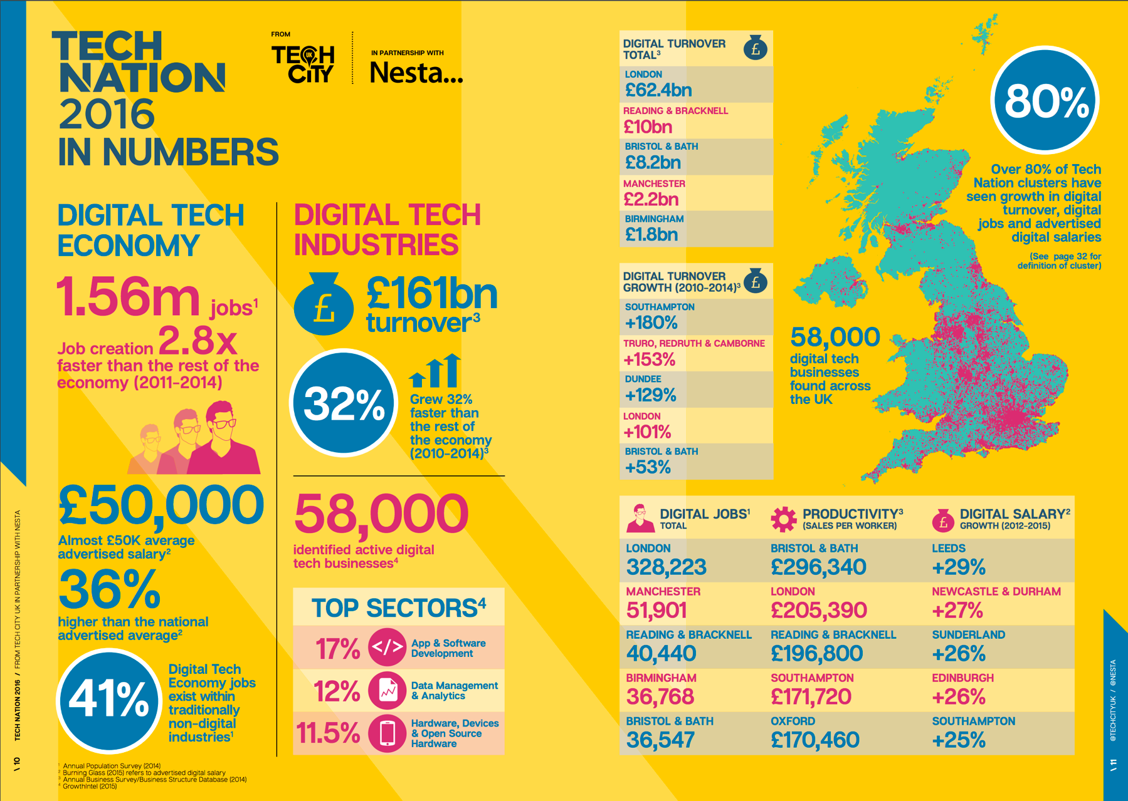

F**igure 4 – 2016 Tech Nation Report**

All of these studies present insights into the state of Gantt charts and how they can fit into different workflows. The 2016 Tech Nation Report reveals that with the growth of the creative industry there is a need for more project management tools that cater specifically for these needs.

**4. Project Specification**

This section will outline and justify key decisions taken in relation to both functional and non functional aspects of the artefacts developed (an, for investigative research based products, the specific criteria being investigated). For software applications; multiple platform support, and performance requirements etc should be included in this discussion. This section should be clearly referenced to the project specification document included in the appendices.

# **5. Methodology**

Fellner (2014) reveals that methodologies help to carry out projects comprehensively. If the right methodology is being used, then the process should feel intuitive and accurate. Not using a methodology for projects reduces the success rate. This is down to a lack of structured approach and project control according to Borysowich (2010). With a variety of different methodologies, it was essential to carry out a comparison before deciding which to move forward with. This comparison can be found in Appendix X.

After carrying out a comparison between Agile, Waterfall and Spiral it has been decided that an Agile approach would be used to complete this project successfully. Figure X is a visual diagram of how the Agile methodology works.

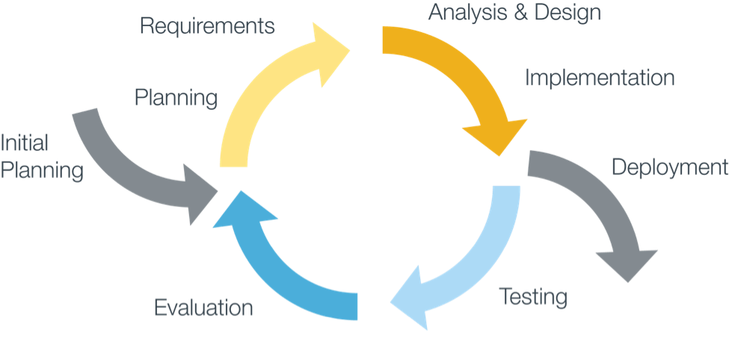

**Figure X – Agile Methodology**

The term Agile for designers can be slightly odd to comprehend as when the methodology came around in 2001 it was primarily aimed at software developers. Joel (2015) explains that despite this Agile can be a very effective method for the design process. It allows for large scale problems to be broken down according to Brooks (2014). As this method is an iterative process it removes the pressure of getting the design right first time. This also allows for user testing and UI changes to be considered and then tested again.

On the other hand, Lillington (2015) argues that working to a fast pace and in iterative sprints the overall quality of the design could suffer. Designing websites and apps takes time and research and this is something that the Waterfall approach allows for. The benefits of gaining user feedback earlier on in the design process outweighs Lillington’s argument. Having the ability to design and roll out new features and functionalities is a lot easier with an iterative workflow.

It was vital that this project stayed on track and within the schedule created, otherwise the final deadline would be in jeopardy. Clum (2013) states that this methodology has a strong emphasis on designing and implementing products and services on-time and in-budget. This methodology also ties in with the process followed at The Idea Bureau, which means that a professional workflow is being adhered to.

Since the project review schedule was created, which can be found in Appendix X. Certain timings have changed and this is due to having to manage another assignment alongside this. Although this meant that a new Gantt chart had to be created, the final deadline was still achieved. If anything it has given more time to create a polished interactive prototype and more thorough user research.

Originally the user research and design phase was meant to be completed by… but it has been pushed forward until … .

* Talk about how all files were version controlled using GitHub

# **6. Design**

## **User Research**

Having an understanding of users when designing user interfaces is essential. There are two types of data that can be collected and these are quantitative and qualitative. Veal (2016) states that inexperienced designers often skip the user research phase and rely on biased opinions to create designs. This is dangerous and can impact clients’ business or service.

For this project a combination of quantitative and qualitative research has been carried out. Using a combination of these methods helped to gain a solid foundation to move forward into the design phase of this project. According to Thelwell (2015) surveys are a great way to collect large amounts of data. Surveys also help to gain a better understanding of the end user and Gray (2014) reveals that an intuitive experience starts with a great survey.

The survey created was made up of eight questions and presented and shared on Typeform. Typeform is an online survey platform that allows users to create customisable surveys that provide in-depth analytics on research findings reveals Funke (2016). The data collected through this tool is all anonymous. This survey was about finding out about user’s habits with existing project management tools, what features should be included in a new tool and if there was room in the market for a new tool. The survey got 25 responses from a combination of project managers and team members working in small – medium sized teams. Results show that 80% of participants felt that there was a gap in the market and the main features required by users were:

* Dependencies
* Assign tasks
* Organisation cards
* Overview of schedules

A full breakdown of the results can be found in Appendix X.

The second part of the user research phase was to carry out five user interviews. Nielsen (2000) reports that interviewing only five participants is needed to gain the most valuable information. Anything beyond this is seen as a waste of time and resources. Figure 5 is a graph supporting Nielsen’s research on this.

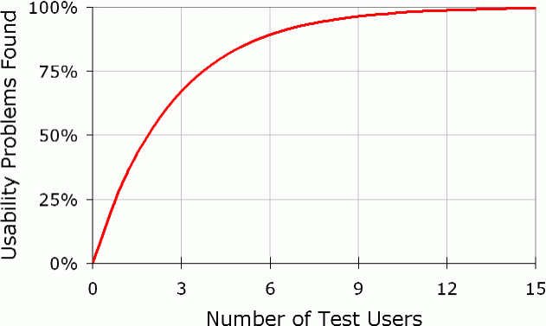

**Figure 5 – Usability Testing Statistics Nielsen Norman**

Since it has been established that the two user types for the project are project managers and team members a variety of these users have been interviewed. This means that both user perspectives have been carefully considered. These interviews have helped to understand the frustrations and pain points of existing tools as well as what works. Transcripts of these interviews can be found in Appendix X.

All of the research gained in this phase of the project has heavily influenced the design of the clickable prototype. Without these research findings the prototype would have been built based on personal experiences with these tools. Taking into consideration a wider audience has definitely helped to create a professional workflow with a detailed end product.

## **Personas**

Personas are a tried and tested part of the UX process as they have been in use since the mid 90’s reveals Goltz (2014a). Usability Gov (2013) explains that personas are about creating realistic representations of different user types. These personas should be informed by user research collected. The more in depth research carried out the better quality personas.

Based on the user research that was collected for this product, two personas have been created for each user type (team member and project manager). These personas have been used as a base for the user journeys. By factoring in personas it makes the process more realistic and relatable both for the client and the designer working on the project. These personas can be found in Appendix X. Meyer and Wachter – Boettcher (2016, pp. 7 – 10) stress that taking into consideration user’s stress cases is important as this is when the application is tested the most. A small case study on why this is required can be seen in Appendix X.

## **User Journey and Empathy Mapping**

* Personas have been used to understand better how users would become aware and engage with the website
* The user journey has been broken down into 4 stages. Awareness, interest, consideration and action

## **Mood Boards**

A mood board was created using InVision boards as a way of storing and collecting design inspiration for this project. InVision boards allow for colour swatches and typography details to be stored alongside screenshots of web pages. This board has been added to throughout the duration of this project as a way of defining a design style. Figure X provides an insight into what this board looks like. However, it can also be accessed by following the following URL:

[**www.hudhjgnfmg**](http://www.hudhjgnfmg)

// Image of InVision board

## **Site Map**

Site maps are a hierarchical diagram that visually show the structure of a website. This is an important part of any design process as it is a way of ensuring that content is where users expect it to be. Defining a site map after the UX phase helps to identify any areas of concern earlier on reveals Mears (2013b). Site maps help to reduce and fix the number of poorly linked internal pages. If the navigation structure of a website is strong then this will improve the overall user experience of the website according to Bigby (2016).

The site map for this project has been designed using a tool called Timblee. Timblee is a free web service that allows users to create high level site maps for websites. This was an easy and hassle free way of creating a site map for Project Pipeline. From this it is easy to see how users would interact with the site and how tasks would be achieved. Figure X is a diagram of the site map for Project Pipeline.

//Image of sitemap

## **Wireframes**

After all of the UX tasks had been completed it was time to move into the design phase. This began with creating low fidelity wireframes of the pages that were going to exist in Project Pipeline. Having the site map mapped out meant that planning for these pages was easy. According to Latus (2016) before starting the wireframe phase a list of the products main features and functionalities should be created. With this in mind hierarchy can be established between components. The best way to achieve these low fidelity wireframes was through pen and paper. This meant that all the ideas were throw away as there was not much investment in them at this stage. It is essential to avoid becoming attached to the first idea. The low fidelity wireframes for this project can be found in Appendix X.

It was important to get feedback on these designs. Doing this at an early stage saved a lot of time later on in the design process.

When the low fidelity wireframes had been achieved it was time to progress them to a medium fidelity. For this Sketch was used to create simple layouts that had more solid layout considerations. There are a variety of tools that could be used for medium fidelity wireframes and a comparison of these can be found in Appendix X. The important thing to remember when creating these wireframes in Sketch was to not get too invested in spacing and typography. Using a basic and stripped back tool would have avoided this altogether. However, for this design process using minimal software tools was essential in having a smooth and reliable process. This was a really part of the design phase as it was reassuring to know how the prototype was going to work and how the complicated design was going to fit in a single view port. It also helped to gain a better understanding of the information architecture. The medium fidelity wireframes can be found in Appendix X.

## **Branding**

* Drawings of logo ideas
* Experimenting in Sketch
* Colour Palette
* Typography considerations
* Iconography

## 

## **Design**

Once all of the wireframing had been done it was time to move into high fidelity mock-ups. This required using industry standard software to create a high end final output. A comparison of the latest industry standard software can be found in Appendix X.

It was decided that Sketch was going to be used to create the UI for Project Pipeline. Sketch is a simple and easy to use design programme with a clean interface. The minimal interface means that there are no unnecessary tools on show, which can often make users feel overwhelmed. Sketch has a vector driven environment so it means that all components are easy to scale and resized according to Andrew (2016). Avocode (2017) reveals that there are now more designers using Sketch than Photoshop. This is mainly because of the constant updates that are released with Sketch. Figure X shows the statistics of Photoshop vs Sketch users.

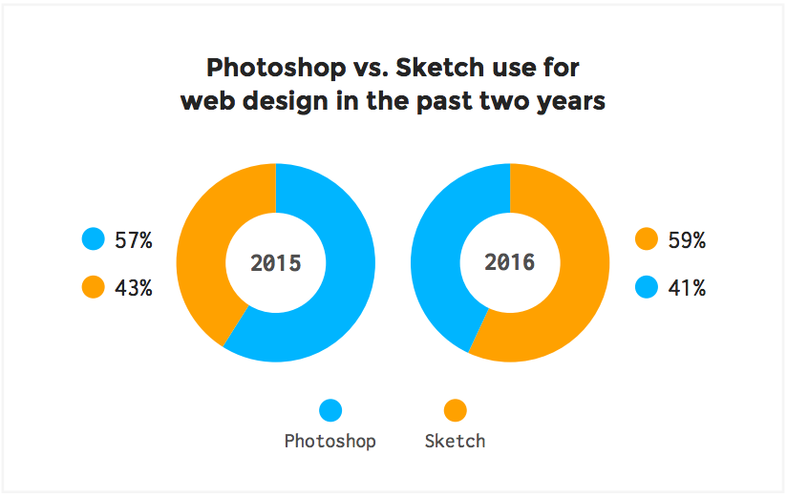

Sketch is incredibly powerful because of all the plugins that can be used with the software. A list of the plugins and a description can be found in Appendix X.

When first creating a new Sketch file it was really important to make sure that artboards were organised. As there were a lot of screens it meant that being able to easily navigate was vital. Pages have been created inside the Sketch file to indicate different features. Figure X shows how this was achieved.

//Screenshot of page names in Sketch file

It was also important to make sure that all layers were named appropriately and symbols were used when required. Sketch is really powerful for allowing users to create nested symbols for repeated styles. This ensures that there is design consistency. Figure X shows how symbols were used in this proect.

//Screenshot of symbols

When the structure of the file was set up right it was time to start experimenting with colour palettes and typography options. The design of this project management tool was made to be minimal and colourful. Research into Google Material Design colours helped to choose a bright and consistent colour palette. The main colours used in the design can be found below in Figure X.

//Colour swatches

The fonts used in the design have been downloaded from Adobe Typekit. A great amount of time went into sourcing fonts that were right for the design. When it came to selecting font sizes the modular scale was followed. This allos for type sizes to work well and be meaningful. The modular scale refers to line height and type face sizes report Brown (2011). In order to calculate the font sizes the modular scale website is going to be used. The final fonts chosen work really well and more details on this can be found in the style guide.

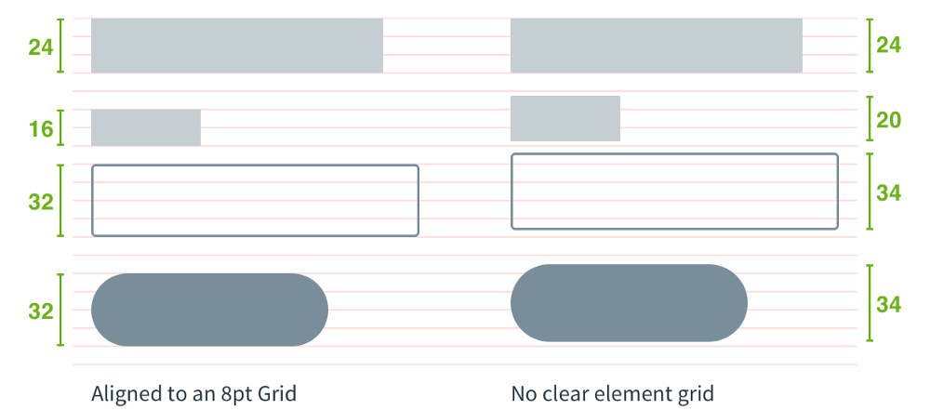The next step was to decide on what grid the designs were going to fit to. After reading in to Bryn Jackson’s articles on the 8px grid system it was decided to work to this. Introducing the 8px grid system meant that there was greater consistency. Figure X shows a comparison of how components lie on and 8px grid vs no clear grid.

There have been a lot of articles recently talking about a component driven workflow in Sketch. This is something that has been adhered to in the design process. It is based on Brad Frost’s atomic design principles and more information on this can be found in Appendix X.

## **Prototyping**

Prototyping allows for designers to better communicate concepts and ideas with the wider team and clients. This means that everyone involved within this process can provide feedback and suggestions on improvements. These feedback comments can then be refactored into the design before the development phase begins according to Sandu (2016). Mejia (2016) explains that there are a variety of prototyping tools available to users. The purpose of these tools is to bring ideas to life and convey concepts clearly. When deciding on what tool to use it comes down to personal preference reveals Mockplus (2016). A comparison of these tools can be found in Appendix X.

InVision was the prototyping tool used for this project and it worked really well in creating a clickable prototype. This is a simple tool that allows designers to create interactions between artboards. There are also commenting features, which allow feedback to be recorded easily states Order Group (2015). In order to get the artboards from Sketch into InVision the Craft plugin was used. This provides one click syncing and this made it really quick and easy to import the large quantity of artboards. When creating the prototype there were a lot of clickable hotspots that needed repeating on all pages. This was easy to achieve in InVision using Hotspot templates and saved a lot of time when putting together the prototype. Figure X is a screenshot of how these hotspot templates were created.

//screenshot of creating hotspot template

Once the prototype was completed a shareable URL was created so that the prototype could be tested with users. Having previous experience with using InVision for user testing made this process a lot smoother. The completed prototype can be accessed following the following URL:

**www.hudhjgnfmg**

## 

## 

# **7. Issues arising from Implementation and Test / Conduct of the Investigation**

This section will discuss the issues / problems that arose during implementation and testing or the conduct of investigation (whichever is appropriate to your project) and how each was resolved. This section will provide evidence of your problem solving abilities and should clearly indicate that you are willing to look to external sources for information and develop your personal skill set in order to resolve problems. It may be appropriate to include short extracts of code or a few illustrations / screenshots in this section to illustrate the issues you are discussing. Where you wish to discuss large or more numerous artefacts, these should be included in the appendices and referenced in this section. This section should also include a discussion of variations on your project monitoring and control.

* User testing feedback
* How many users was the prototype tested on?
* How was it done?
* What could be done differently?
* Did the prototype solve the problem for users?

# **8. Results**

This section summarises and provides evidence of what has been achieved and will reference additional materials in appendices. For projects that test a theory of concept it will analyse the results of the investigation in relation to original expectations and draw conclusions about the theory or concept.

- What does the user feedback show?

- Positives / negatives

- Improvements to be made

# **9. Evaluation and Conclusions**

This section will evaluate both the process and products of your project based on your previously developed criteria. Note that the products of your project include not just the principle artefact that you have developed but also design and other documentation associated with the development process. It is also appropriate to discuss the results of any external validation of your artefacts in this section. The evaluation of the process should consider all elements of your project methodology as well as project management issues.

* How did the process go?
* What could be improved next time?
* Was the project successful?
* Did I meet the criteria for success?
* Is the final product at a high enough standard?
* What were TIB thoughts on the final product?
* What did users think of the product?
* Would this tool be successful?

# **10. Recommendations for Further Work**

Based upon your evaluation of the process and products of the project as a whole you should make recommendations about how the project could be carried forward in the future. For example, what improvements could be made to your system or experiment if you were to continue further work on your project? If your project was re-scoped at the review stage in order to ensure it was achievable, this section is likely to discuss elements remove at that point. If your project consisted of creating a design document for a complex system, it might discuss how your design might be implemented.

- Creating an accompanying mobile app for users to see an overview of schedules and availability of team members.

- User research showed that this would be a valuable but not essential feature, which is why this hasn’t been designed and implemented within the project timescale this time round.

- More in depth work into the branding of Project Pipeline. Considering branding isn’t a strong point and the focus of this project was about creating an intuitive interface.

# **10. Appendices**

## ../../Screenshots/Question%203.png../../Screenshots/Question%202.png../../Screenshots/Question%201.png**Appendix X – Survey Results**

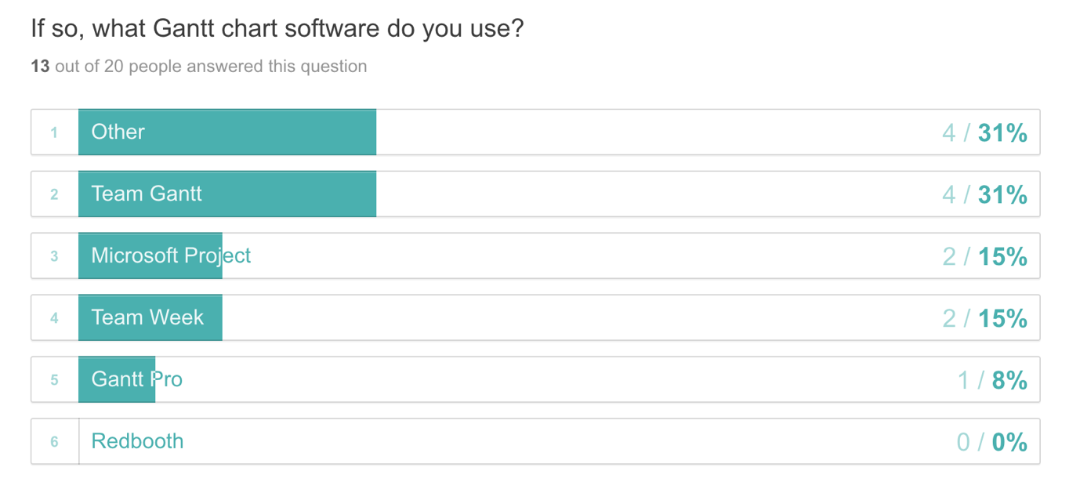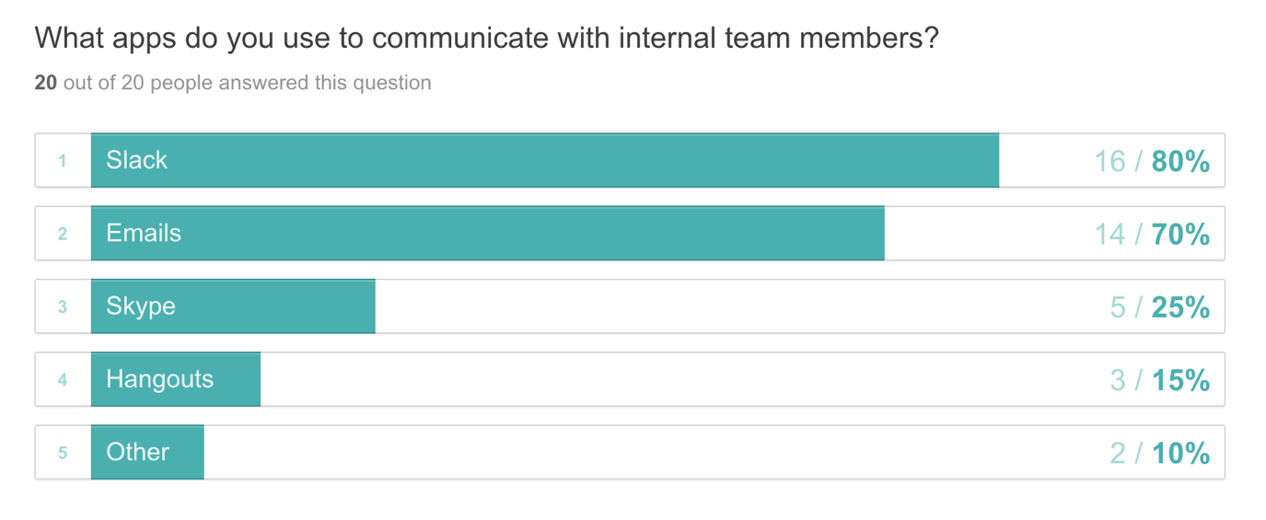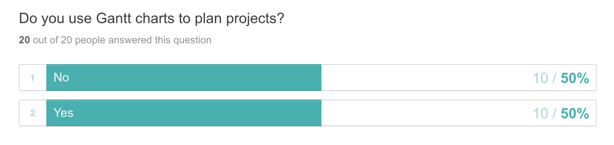

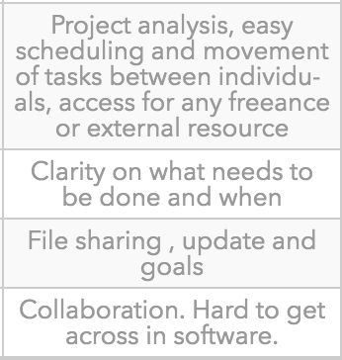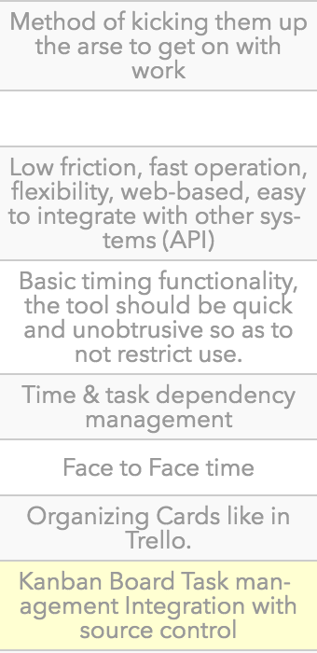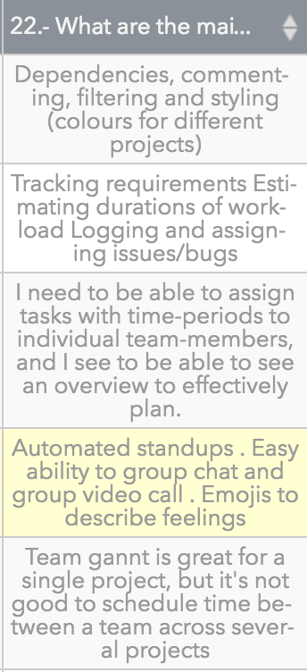

What are the main features / functionalities you require to successfully project manage a creative team?

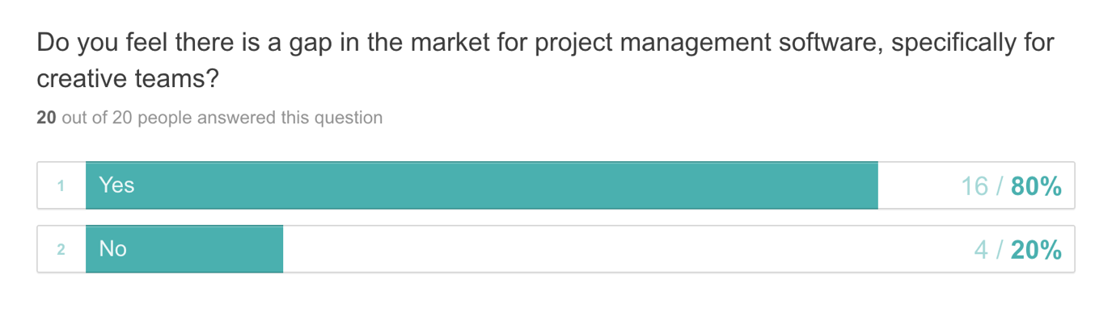

## **Appendix X – User Interviews**

**User Interview – Male, Front End Developer**

**Me:** So how do you feel about having to follow a project plan?

**Interviewee:** Umm, yeah, I make sure I know what I’m doing before the day or the week. So I think project plans are very important just as your daily schedule.

**Me:** Cool, and what do you think makes it a good experience or a bad experience?

**Interviewee:** So that’s when everything is thought through and you have a got a lot of things planned out in advanced. And so you have a clear cause of action.

**Me:** Cool, and do you feel that having a project management tool that works responsively is necessary, and if so why?

**Interviewee:** Yeah completely, it’s got to work on all screen sizes because you might check it on your phone in the morning or your watch when you’re out and about. Or you might pop it up on your iPad or the big screen.

**Me:** And do you think that being able to integrate apps with the tool will be useful? And what apps do you think would be valuable.

**Interviewee:** Yeah, um if it could integrate with services that people use I mean definitely. It’s got to work with things like calendars, Google calendars is a great one. And maybe stuff like emails and messaging services like Slack. Then you could get daily updates and things which is perfect.

**Me:** Cool, and what tool do you currently use for your projects?

**Interviewee:** At the moment we’re using Teamweek, which is cool. That at the moment integrates with Slack and emails and things as well.

**Me:** And what features do you like and dislike about the tool?

**Interviewee:** It’s nice and easy to use. It’s got a couple of different views, so you can go down and see what your schedule is or more of an overview or like a month view. So you can check out different projects and time ranges.

**Me:** Yeah, but you can’t have dependencies can you? So I guess that’s something its lacking?

**Interviewee:** Yeah Teamweek is very focused on a person kind of view. So it’s not a typical Gantt kind of thing.

**Me:** Are there any features that you feel should be a part of a new project management tool that’s being designed, specifically for creative teams?

**Interviewee:** Specifically, for creative teams?

**Me:** That would be like small to medium sized teams as well

**Interviewee:** Yeah, I think a good thing there is applying details such as time tracking because that’s very important in I’d say the smaller industry at the moment, so that you can relay that back to clients. Other than time-tracking, I’d say just integrating with the services that teams use to communicate. That’s about it really for me.

**User Interview – Male, Full Stack Developer**

**Me:** How do you feel about having to follow a project plan? Do you find they become quickly outdated?

**Interviewee:** When you say ‘follow a project plan’ do you means as a developer or someone managing a project?

**Me:** As a developer

**Interviewee:** It’s super useful to have one, especially for bigger projects. We always have some form of plan for a project, even if it’s just a conversation in the office (for smaller jobs). They remove some of the stress of having to deliver a project on time as it’s often broken down ahead of time with sensible deadlines. As long as I hit those, I don’t need to worry about the impact of other projects on scheduling.

**Me:** Yeah, that makes sense. Have you had any experiences where a projects plan has gone really bad and impacted significantly on other projects in the pipeline?

**Interviewee:** Yes. That’s normally due to underestimating how long something will take and not the fault of the project plan directly. We had a project run 2x longer than it should have. Was difficult delivery all of the other projects we promised.

**Me:** Do you feel that having a project management tool that works responsively is necessary?

**Interviewee:** Responsively as in media queries or automatically pushed projects back?

**Me:** As in media queries. So being able to access project schedules on mobile / tablet devices.

**Interviewee:** I would say there is a use-case for it. Whether it needs exactly the same functionality it a different question. I don’t do this, but it might be that Joe or Susan are with a client and they ask “When can we expect this done by?”. Being able to look at the schedule on your phone or iPad may be useful. Realistically, we would probably just get back to them later. But we should be able to view at least some of the information on mobile in my opinion.

**Me:** Yes, so I’ve got the idea of having full functionality to create / edit project schedules on desktop and laptop devices, but only provide overviews of schedules on tablet / mobile. So it’s great to hear what you think on that. The next question is about having the ability to integrate apps with a project management tool. This could be anything from time tracking software to Slack. Do you think this is beneficial and what apps do you think would be essential?

**Interviewee:** It’s a bonus being able to do those things. I’d probably avoid time tracking tools as I think they will be unrepresentative of how much work has been done or is left to do. Especially as estimates are never 100% accurate. For example, on a current project I’ve spent 155 hours of 210 hours. The project management tool then thinks “Oh, we are 74% complete” but realistically I have another 70 hours left on it. We find it easier putting in high level progress percentages, which is given from the developer. So in this case, I’d say we are 60% done. Slack could be a good integration. Maybe ping a message to a project specific channel with messages like “X deadline in 14 days or X task completed ahead of schedule”.

**Me:** Cool, what tools do you currently use to manage your projects? And what do you like / dislike about them?

**Interviewee:** That is a question for Susan, as she actually does a lot of that now. We don’t have access to it, because I don’t think we need access to it.

**Me:** Okay cool, that’s interesting. So you don’t even see an overview of a project timeline or anything? How do you know your schedule?

**Interviewee:** Nope! My brain doesn’t need to be filled with that information as it doesn’t gain anything. I can’t do anything else as a developer. My job is to deliver work on time. I shouldn’t have to know about all the projects we have on, including ones that I am not involved in. We have a catch up in the office where Susan outlines what she would like people to work on. If things start to get behind, then she can see the impact of that and manage client expectations. A typical conversation is “Adam, you’re on project X for 2.5 days and project Y for 2.5 days. Joe we need A, B and C done this week. Do them in any order that suits you but we need them done. Tom, you’re doing designs this week for X client.”

**Me:** That makes sense! I hate knowing the ins and outs of every project. Especially when you aren’t involved at all.

**Interviewee:** Yeah, one person needs to. And that person also needs to know what expectations have been set with the clients.

**Me:** Last question. Are there any features that you think should be part of a project management tool specifically for creative teams?

**Interviewee:** Do the actual work for them too? Again might be a question for Susan as she uses it more. But being able to set hours-per-day (per resource). We work 7.5 hours a day. But we might have someone else on the team who works half a day (like an intern). Maybe being able to list the skills required to complete a task in a project. Might make it easier to assign resource to it for a bigger team.

**User Interview – Male, Project Manager**

**Me:** So how do you feel about having to organize and follow project plans?

**Interviewee:** Organising and following project plans are essential to ensuring a projects success, without a plan the project would essentially be a nebulas amount of work that needs to be completed but there’s no expectations of when or how it’ll be done.

**Me:** What makes this a good or bad experience?

**Interviewee:** Undoubtedly the software that you use will result in a good or bad experience, using no software and relying on scraps of paper is almost definitely going to end badly. Good software on the other hand can speed up the process and give clarity to all involved in the project. That said it does rely on all involved in the project to be onboard with the software, otherwise it’s just another point of failure.

**Me:** Do you feel having a project tool that works on tablet and mobile devices is necessary? If so, why?

**Interviewee:** Definitely from a from high-level, I’d want to be able to look at tasks or add notes on a mobile or tablet device. Otherwise these small tasks will need to wait until I’m at a desk or force me into pinch, zoom and drag hell assuming the tool isn’t mobile friendly.

**Me:** Would you find value in being able to integrate apps into a project management tool useful? And if so, what apps would be valuable?

**Interviewee:** Absolutely. Where possible we’d like the tool to integrate with all the other software we use to communicate as a team. For us the most important integrations would be Slack and FreeAgent.

**Me:** What current tools are you using for your project plans?

**Interviewee:** Right now we use Teamwork, previously we used Trello but moved away from it because it became a big soup of projects with no real clarity as to what needed to be done per project without forcing you to dive into a particular project.

**Me:** What features do you like and dislike about these tools?

**Interviewee:** As of yesterday Teamwork released Boards within projects which gives us the same flow as Trello. This is really important to us as we are now able to visualize progress to a client without producing old school Gantt charts (which it will produce for your as well). We love this tool and can’t think of any functionality we dislike.

**Me:** Are there any features you feel should be part of a new project management tool that’s specifically for small – medium sized creative teams?

**Interviewee:** Aside from the integrations mentioned above Teamwork does everything we need it to do for us right now.

**User Interview – Female, Project Manager**

**Me:** So the first question is about how do you feel about having to plan projects for a team and what makes it a good or bad experience?

**Interviewee:** Good things is that you know what’s happening in the near future and who is working on what and when. You can see what projects are on track and on budget. It also helps to plan future work and update clients on the progress of their project. Bad things would be when you hit a couple of problems and a project overruns. Or when a team member is unwell, you then need to find solutions and rework the schedule. This can be stressful.

**Me:** Cool. Do you think that having a project management tool that works on mobile and tablet devices would be useful? It may not have the same functionality as the desktop site but just provide an overview of schedules.

**Interviewee:** Yes definitely. Especially when having a meeting with a client and you’re out of the office. Can answer any scheduling queries there anre then.

**Me:** Would being able to integrate aps into the project management tool be useful? This could be anything from time tracking to Slack.

**Interviewee:** Yes, I think so. Slack especially. What I’d love is an all in one tool. Instead of having 4 – 5 different applications that you have to pay for and jump between.

**Me:**  Yeah definitely! Makes it all easier to maintain. What current tools are you using? And what do you like / dislike about them?

**Interviewee:** So I currently use Slack, Flow, Pipedrive, Hub Planner, Toggl and Team Gantt. Slack is used to talk to the team and send links etc. I like that its quick to communicate and share files and I dislike threads. These sometimes hide content, which means I miss it. Flow is what I use for my to do list. I can set reminders for future dates and make sure I finish my checklist for the current day. I like that it allows me brain dump all my jobs I need to do for the day. I can set recurring weekly / monthly / annual to do’s so I never forget tasks. This tool is only really suitable for small reminders. Sometimes I need notes with the task, but limited by the word count. Pipedrive is where sales leads and records of meeting notes or important points from calls. A CRM that has all contact details and project updates. So if I’m away Joe can see where we are with each project and last contact etc. I like that it is easy to find projects and update their statuses. I dislike that sometimes it’s hard to find previous emails attached to a client. It can take a while to find what I need to reference. Hub Planner is used to schedule all the work and assign to each team member. It’s great to see an overview of what projects we’re working on and when. I can also easily move things around. Allows me to see if we have capacity to take on another project. I dislike that there is a limit on how much detail you can add to the phases. Hence why Team Gantt is needed to break these down further. Toggl is what we use for time management. It allows me to see how much time has been spent and keep an eye on budgets. I like how I can see detailed reports for each project and their various tasks. Although the summary report is lacking and usually wrong. I always have to go to the detail report to get the correct data. And we also use Team Gantt for Gantt charts with milestones and detailed proposed timelines for each element of a project. I like how it allows you to break down all phases into tasks and add dependencies based on previous tasks. You can put percentages on each one for their completion status. The design is outdated and horrible to use though.

**Me:** This is really helpful. The last question is what features do you feel should be part of a new project management tool that’s aimed at small – medium sized creative teams?

**Interviewee:** What I’d love is an all in one piece of software that does the following. Be an easy, flexible planner for ongoing projects, provide an overview that shows what projects are booked in and scheduled. This should then offer a more detailed plan (Gantt chart) for the project. Having channels for each project that allows for quick file sharing / chats to the team. A to do list would also be good so that you can add to any date and recur if necessary. Being able to integrate with the CRM to see client details and all correspondence. The ability to manage time like Toggl. This would show what time has been logged against each project. So, not much! I hope that helps and let me know if you find a solution.

**User Interview – Male, Project Manager and Designer**

**Me:** How do you feel about having to organise and maintain project schedules?

**Interviewee:** I feel great. It’s a core part of a running a team. It’s not an easy task, especically in client services.

**Me:** Awesome, what makes this a good or bad experience?

**Interviewee:** The tools play a huge part in this. The user experience, including performance of the tools we use make such a big difference.

**Me:** Do you feel that having a project management tool that works on mobile and tablet devices is necessary? And if so, why?

**Interviewee:** Yes! Schedules change all the time and we need the tools to be able to adapt whenever we need to. It’s not essential that a planning tool doesn’t work on mobile but it can help.

**Me:** Would you find value in being able to integrate apps into a project management tool useful? And if so, what apps would be valuable?

**Interviewee:** Yes! I’d love this! I’d love to be able to integrate with our staff holiday app (timetastic). Also Basecamp (our PM / Project Comms app) and also Slack (our team internal chat tool).

**Me:** Cool. What current tool(s) do you use to plan projects?

**Interviewee:** Apple Calendar, Teamweek and Basecamp.

**Me:** What features do you like and dislike about these tools?

**Interviewee:** Teamweek is okay but would prefer something which can provide greater integration, bigger picture views and an understanding on billing and missed plans.

**Me:** Are there any features you feel should be part of a new project management tool that’s specifically for small – medium sized teams.

**Interviewee:** Project filtering is important. Understanding a difference between planned commitments and also TBC commitments. That would be sweet.

## **Appendix X – Personas**

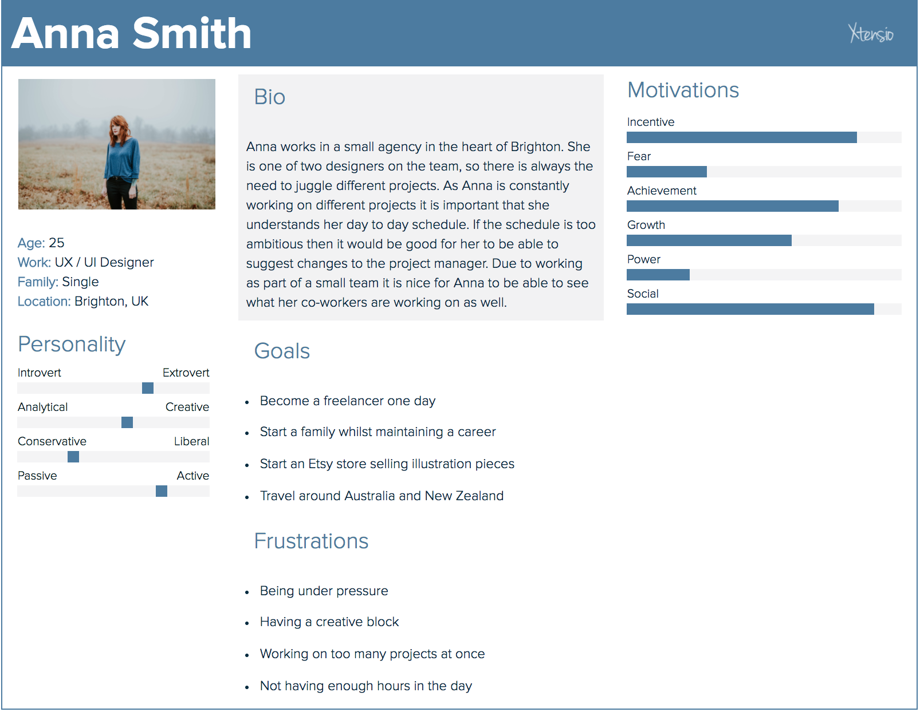

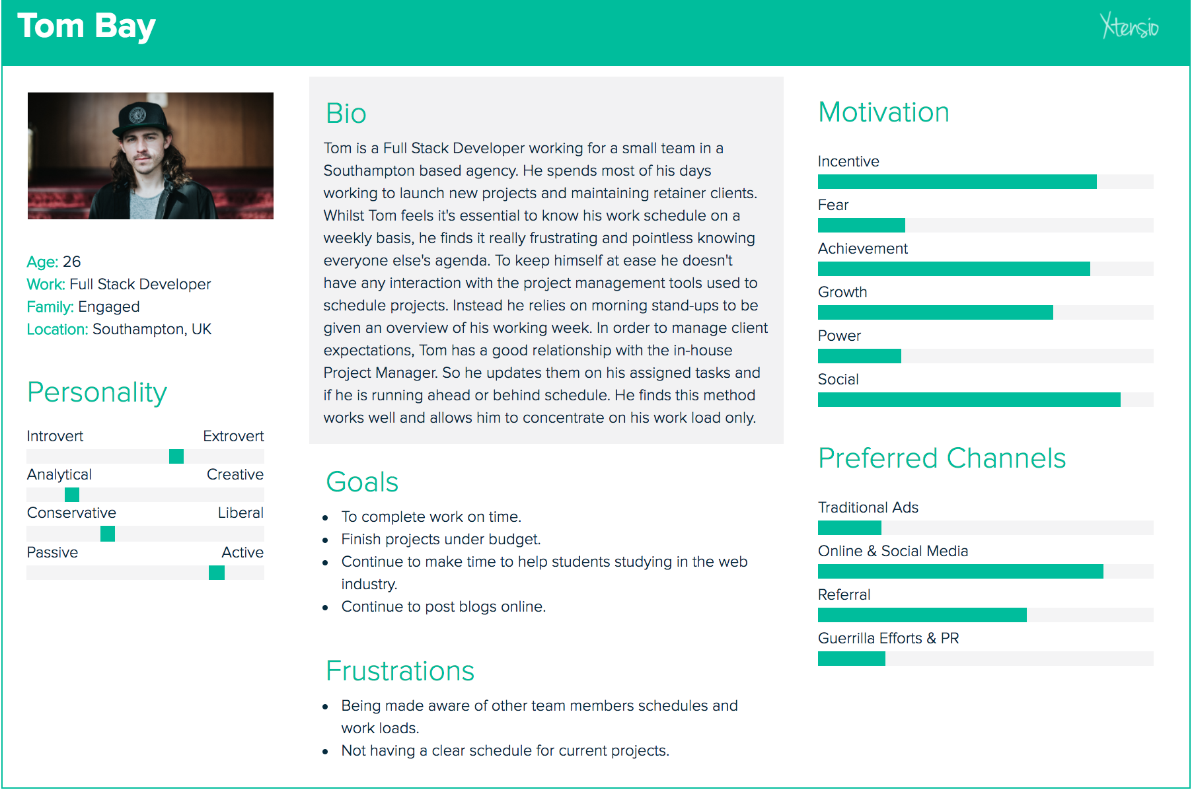

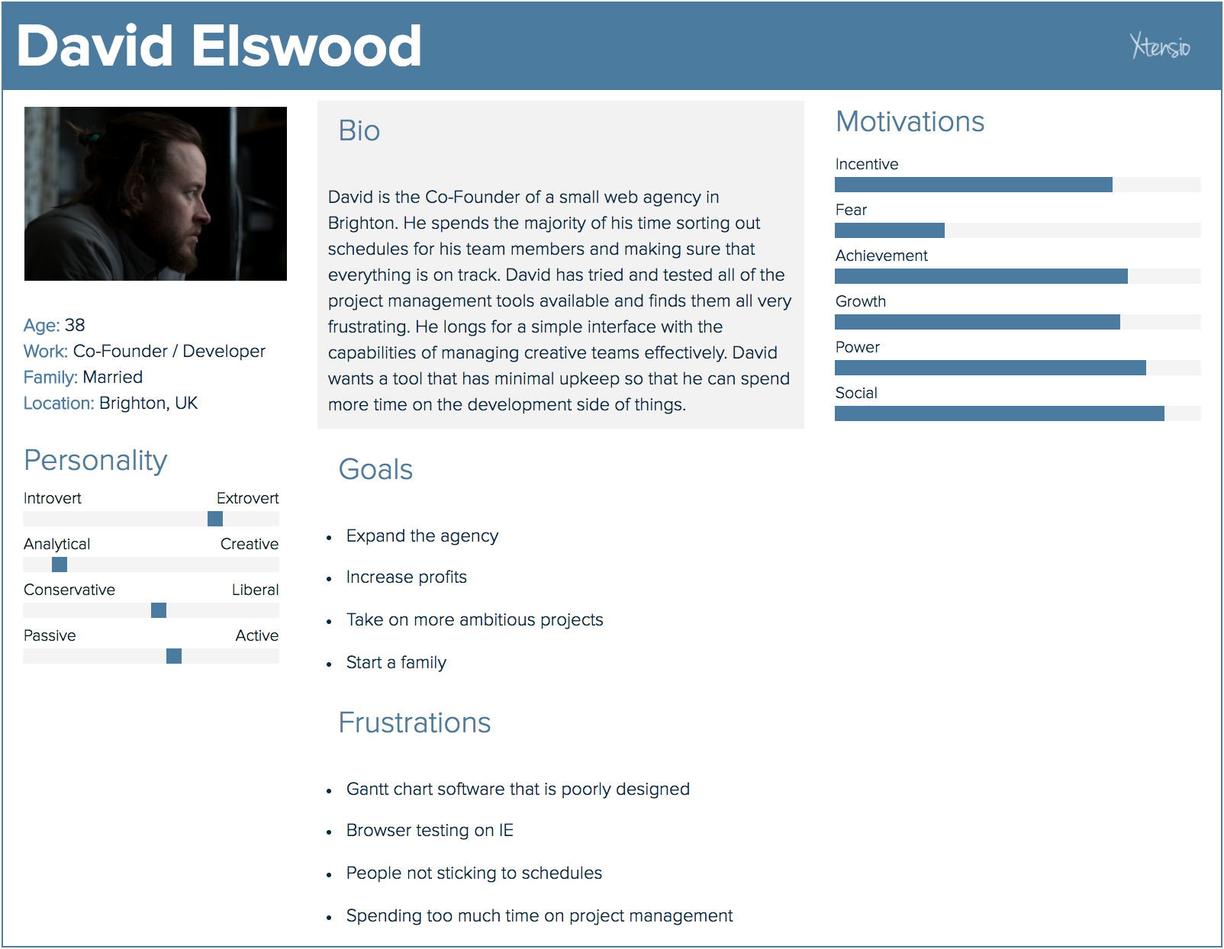

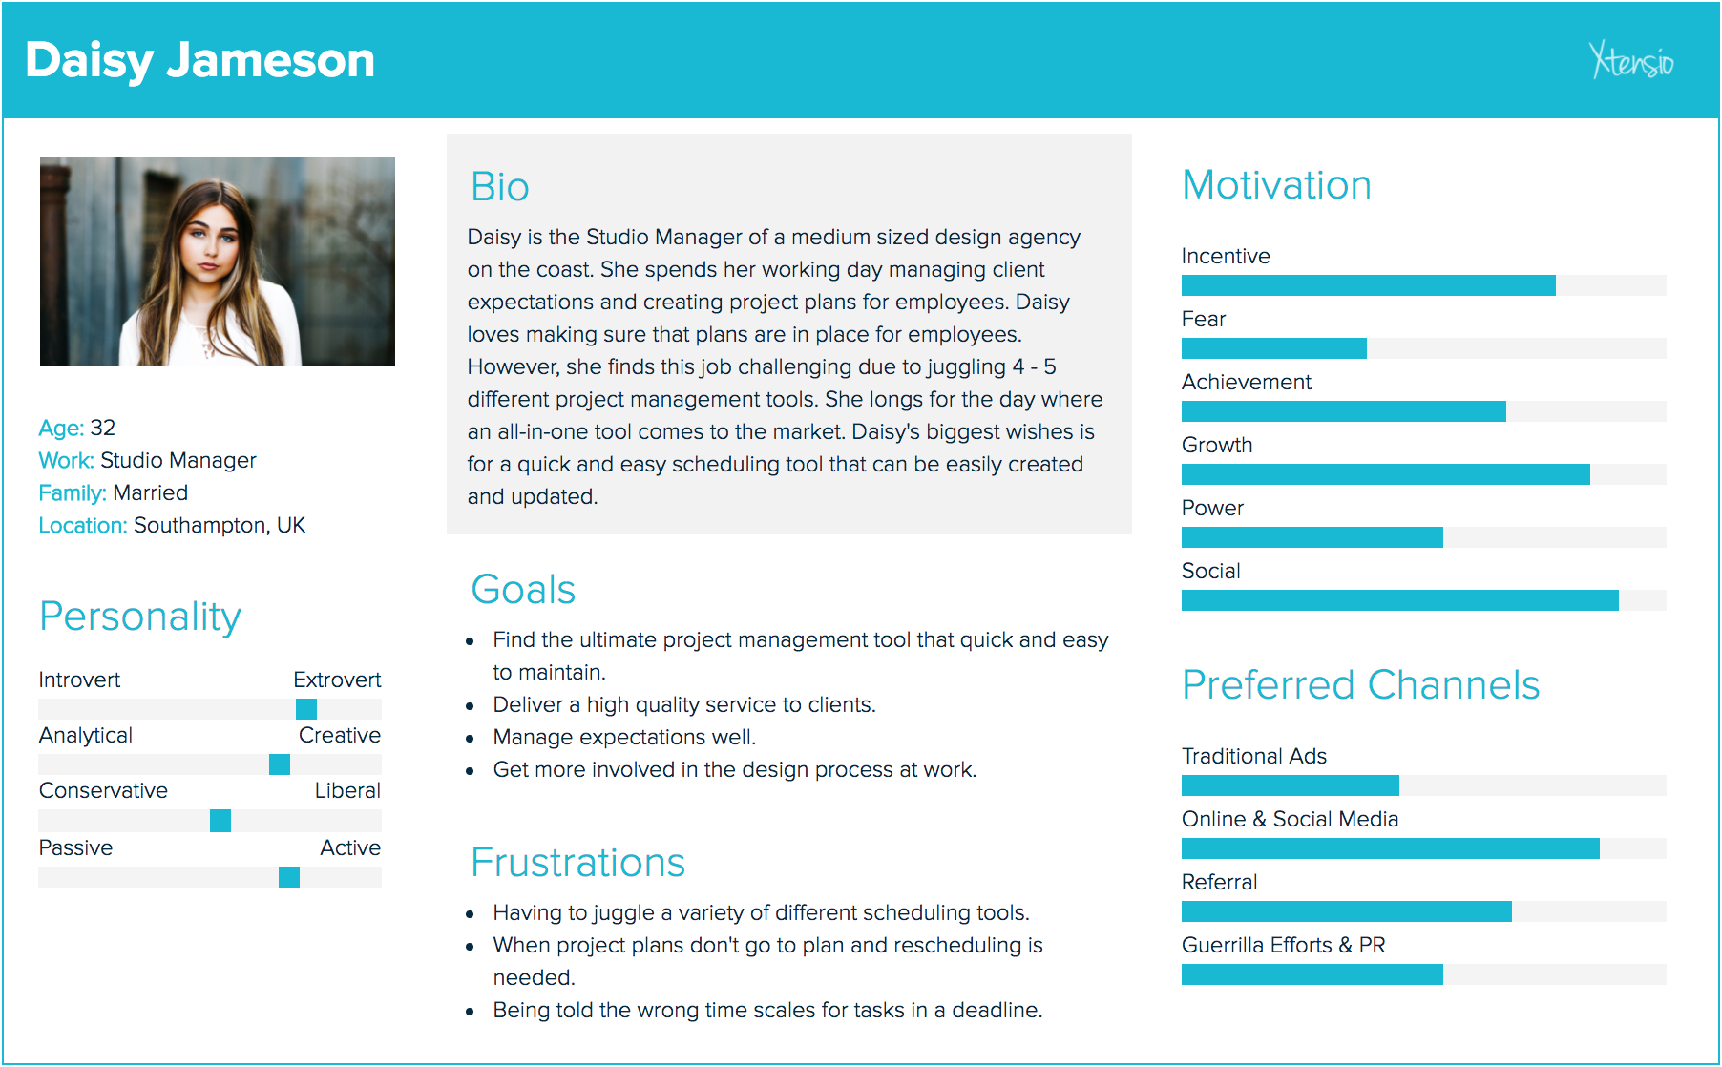

Appendices

* UX Case Study
* Waterfall Methodology
* Spiral Methodology
* Competitors Analysis
* Competitors Analysis
* Competitors Analysis
* **Personas**
* Low Fi Wireframes
* Medium Fi Wireframes
* High Fidelity Wireframe
* Style Guide
* **Survey Results**
* **User Interview Transcripts**
* Comparison of Prototyping Tools
* Comparison of Medium Fidelity Prototyping Tools
* **Sketch Plugins**
* Atomic Design Overview

## **Appendix X – Sketch Plugins**

|  |  |
| --- | --- |
| **Plugin** | **Description** |
| Nudg it | Nudg it allows users to set different spacing rules to the default ones in Sketch. This is particularly helpful when working to an 8px grid. In this instance the small nudge would be set to 1px and the large to 8px. This works really well and is hassle free. |
| Swatches | This plugin provides users with colour swatches of multiple different collections. There are Pantone swatches along with Material Design. This is a simple tool that prevents users from having to look online for these colour swatches. These can easily be added to global or document colours within a Sketch file. |
| Craft | Craft is a tool created by InVision to make Sketch more powerful. It adds multiple features:   1. InVision Sync allows users to upload all or selected artboards directly into InVision projects. This enables the Inspect feature to be used by developers. Inspect provides insights into layout padding, margins etc. 2. There is the ability to create libraries of styles. These can be shared with other team members working on the same project. 3. Craft allows users to use real content within designs. This can be anything from photography to copy. 4. There is a duplicate feature that allows designers to duplicate layer groups. This could be helpful for a design that has multiple blog post objects. 5. Freehand is a new tool that has been released. This allows users to share artboards with collaborators and comment / draw to present feedback on designs. 6. Ability to add photographs to artboards from Unsplash. |
| Auto Layout | Auto Layout helps to create responsive designs in Sketch It helps designers to stop designing for mobile, tablet and desktop devices and to think about the view port sizes in between. Although Project Pipeline is not a responsive design this tool has been used in preparation for future design work. |

## **Appendix X – Comparison of Medium Fidelity Wireframing Tools**

|  |  |  |
| --- | --- | --- |
|  | **Advantages** | **Disadvantages** |
| **Sketch** |  |  |
| **Balsamiq Mockups** |  |  |
| **Omnigraffle** |  |  |

## **Appendix X – Comparison of Prototyping Tools**

|  |  |  |
| --- | --- | --- |
|  | **Advantages** | **Disadvantages** |
| **InVision** |  |  |
| **Marvel** |  |  |
| **Just In Mind** |  |  |